IMPLEMENT CLIENT SCRIPT & UI POLICY (INCIDENT)
ServiceNow Project Documentation

1. Problem Statement
Incident records require consistent and accurate data entry. Manual checks can lead to incomplete, inconsistent, or incorrect submissions. This can affect reporting, SLA tracking, and service quality. UI-level controls are therefore required to guide users and validate important Incident fields.

2. Objective
The objective is to demonstrate ServiceNow client-side controls that maintain data integrity. UI Policies and Client Scripts are used to dynamically make fields mandatory, automatically populate values, control field behavior, and prevent invalid submissions or list-edit changes.

3. Skills / Technologies
- ServiceNow Incident Management
- UI Policy
- UI Policy Actions
- Client Scripts
- Form Validation

4. Main Workflow
Condition | Control | Expected Behavior
Impact = High | UI Policy | Assignment Group becomes mandatory
Impact = High | UI Policy Action | Urgency becomes read-only
Impact changes to High | onChange Client Script | Urgency is set to High
High Impact + no Assigned To | onSubmit Client Script | Save is prevented
State changed from list | onCellEdit Client Script | List edit is blocked

Task 1: Create UI Policy on Incident

Activity 1: High Impact Control
- Navigate to System UI → UI Policies.
- Click New to create a UI Policy.
- Enter Name: High Impact Control.
- Select Table: Incident.
- Set the condition: Impact is 1 – High.
- Create the UI Policy Action so that Assignment group becomes mandatory.
- Enable Reverse if false where required and save the policy.
Expected Result: When Impact is High, the Assignment group field is enforced as required.

Task 2: UI Policy Action – Urgency

Activity 1: Configure Urgency Behavior
- Open the High Impact Control UI Policy.
- Go to the UI Policy Actions related list and click New.
- Select Urgency as the Field name.
- Keep Mandatory and Visible as Leave alone.
- Set Read only = True.
- Click Submit.
Figure 1: UI Policy Action – Urgency Configuration
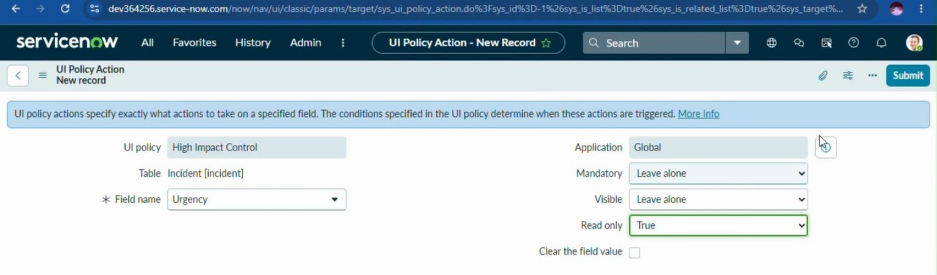
Verification: For a High Impact incident, Urgency becomes read-only according to the configured UI Policy Action.

Task 3: onChange Client Script

Activity 1: Auto Set Urgency for High Impact
- Navigate to System UI → Client Scripts → New.
- Enter Name: Auto set urgency for high impact.
- Select Table: Incident.
- Set Type to onChange.
- Set Field name to Impact.
- Keep the script Active.
- Add the required onChange script and click Update.
Script:
function onChange(control, oldValue, newValue, isLoading) {
if (isLoading || newValue == '') {
return;
}
if (newValue == '1') {
g_form.setValue('urgency', '1');
g_form.addInfoMessage('Urgency set to High for High impact incident.');
}
}
Figure 2: Auto Set Urgency Client Script
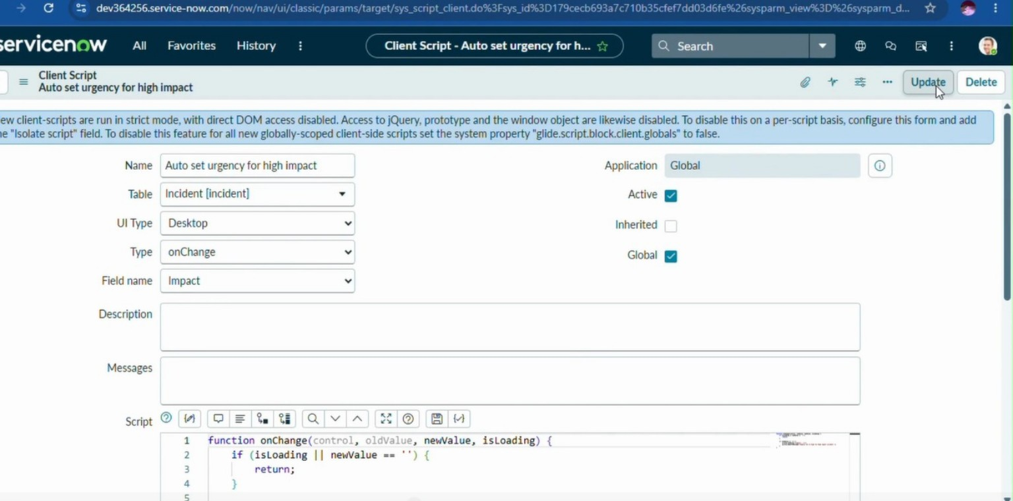
Verification: Changing Impact to High automatically sets Urgency to High and displays the configured information message.

Task 4: onSubmit Client Script

Activity 1: Prevent Save if Assigned To is Missing
- Navigate to System UI → Client Scripts → New.
- Enter Name: Prevent save if Assigned To missing.
- Select Table: Incident.
- Set Type to onSubmit.
- Set the script to check whether Impact is High and Assigned To is empty.
- Display an error and return false when the validation fails.
- Return true when the record satisfies the condition.
Script:
function onSubmit() {
if (g_form.getValue('impact') == '1' &&
g_form.getValue('assigned_to') == '') {
g_form.showErrorBox(
'assigned_to',
'Assigned To is mandatory for High impact incidents.'
);
return false;
}
return true;
}
Expected Result: A High Impact Incident cannot be saved until Assigned To is provided.

Task 5: onCellEdit Client Script

Activity 1: Prevent State Change via List Edit
- Navigate to System UI → Client Scripts → New.
- Enter Name: Prevent state change via list edit.
- Select Table: Incident.
- Set Type to onCellEdit.
- Set Field name to State.
- Keep the script Active.
- Add the script that shows an alert and calls callback(false).
- Click Submit.
Script:
function onCellEdit(sysIDs, table, oldValues, newValue, callback) {
alert('State cannot be updated using list editing. Please open the Incident.');
callback(false);
}
Figure 3: Prevent State Change via List Edit
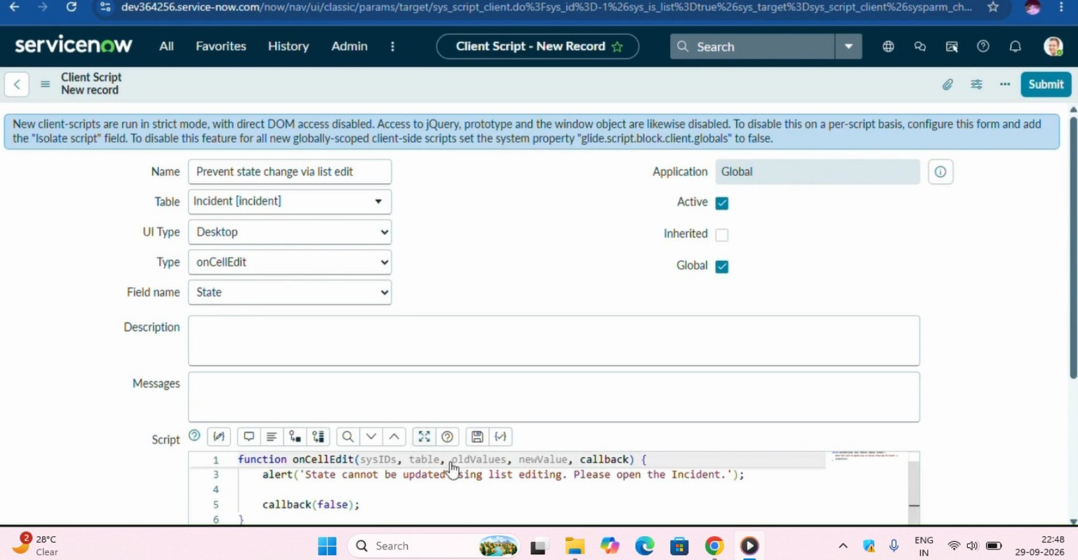
Verification: Directly editing State from the Incident list is blocked. The user is instructed to open the Incident form instead.

Task 6: Testing and Verification

Activity 1 – Mandatory Enforcement
Create an Incident, set Impact to High, leave Assigned To empty, and submit. The save should be blocked.

Activity 2 – Successful Save
Provide Assigned To and submit. The Incident should save successfully. Check the automatic Urgency behavior and configured field controls.

Activity 3 – Reverse Condition
Change an existing Incident from High Impact to Medium. Fields configured to reverse should return to their normal editable state.

Activity 4 – List Edit Blocking
Open the Incident list and attempt to edit State directly. The alert should appear and the change should not be accepted.

Activity 5 – Form-Based Update
Open the Incident record itself, change State on the form, and use Update. The normal form-based update should work.

Expected Results
- High Impact incidents receive the configured field restrictions.
- Urgency is automatically set to High when Impact becomes High.
- High Impact incidents cannot be saved without an Assigned To value.
- State cannot be changed through direct list editing.
- Valid changes can still be made through the Incident form.

Conclusion
The Incident UI Policy and Client Scripts work together to enforce dynamic field behavior, automate updates, and prevent incorrect data submission. The project demonstrates the use of onChange, onSubmit, and onCellEdit Client Scripts along with UI Policy Actions to improve data consistency and control Incident updates.
Note: The screenshots are placed immediately after the corresponding configuration steps so that each screenshot acts as visual evidence of the implemented task.

